
American International University-Bangladesh (AIUB)
Faculty of Science and Technology
Automated Financial News Analysis and Recommendation Generation Using Deep Learning and Large Language Models
Md Tanvir Islam Akib (22-47816-2)
Muzahidul Islam Saki (22-47819-2)
Emon Das (22-46599-1)
Mashudh Ahmed (22-47811-2)

A Thesis submitted for the degree of Bachelor of Science (BSc) in
Computer Science and Engineering (CSE) at
American International University Bangladesh (AIUB)
Faculty of Science and Technology (FST)

Fall 2025-2026 Semester
Submission Date: 20/04/2026

Declaration

This thesis represents our original work and does not contain any material previously published or written by others, except where proper references have been clearly acknowledged in the text. We have appropriately recognized the contributions of others to this research, including support in statistical analysis, survey design, data processing, technical implementation, editorial guidance, and any other relevant assistance.
Our efforts from the beginning of the study term have resulted in the substance of this thesis.
We also acknowledge that the copyright owner of each of the contents in this thesis continue to protect them. When necessary, permission to copy these materials has been obtained, and proper credit has been provided. In the case of collaboratively created work, the consent of co-authors has been duly acquired..

Md Tanvir Islam Akib  22-47816-2  Computer Science and Engineering (CSE) | _______________________________  Muzahidul Islam Saki  22-47819-2  Computer Science and Engineering (CSE)
_______________________________  Emon Das  22-46599-1  Computer Science and Engineering (CSE) | _______________________________  Mashudh Ahmed  22-47811-2  Computer Science and Engineering (CSE)

Approval

The thesis titled "Automated Financial News Analysis and Recommendation Generation Using Deep Learning and Large Language Models" has been submitted to the following respected members of the board of examiners of the department of computer science in partial fulfilment of the requirements for the degree of Bachelor of Science in Computer Science and Engineering on (date of defense) and has been accepted as satisfactory.

________________________________  SHAIKAT DAS JOY  Lecturer & Thesis Supervisor  Department of Computer Science  American International University-Bangladesh | ________________________________  MIR MD. KAWSUR  External Examiner  Department of Computer Science  American International University-Bangladesh
________________________________
DR. MUHAMMAD FIROZ MRIDHA
Professor & Head (UG)
Department of Computer Science
American International University-Bangladesh

________________________________ ________________________________
PROF. DIP NANDI MASHIOUR RAHMAN
Professor & Associate Dean Sr. Associate Professor & Dean
Faculty of Science & Technology Faculty of Science & Technology
American International University-Bangladesh American International University-Bangladesh

Acknowledgement

First and foremost, all praise and gratitude belong to Allah, the Most Gracious, the Most Merciful, for granting the strength, patience, and perseverance to complete this research.
We extend our sincere and heartfelt gratitude to our thesis supervisor for their unwavering guidance, scholarly expertise, and continuous encouragement throughout the course of this research. Their constructive feedback and mentorship have been instrumental in shaping the direction and quality of this work.
We are also deeply thankful to the Department of Computer Science at American International University-Bangladesh (AIUB) for providing the necessary academic infrastructure, research environment, and resources that made this study possible.
We would like to thank the Faculty of Science and Technology for upholding an encouraging and vibrant research culture. We would especially want to thank the instructors and course directors whose talks and lectures enhanced our conceptual knowledge of machine learning, large language models, and natural language processing.

We are appreciative to our friends and family who patiently and morally supported us during the most trying times of this study adventure.

Lastly, we thank the open-source community and the companies that created the Hugging Face Transformers library, Google Colab, and Kaggle for providing researchers worldwide with free access to state-of-the-art models and computational resources.

Author Contributions

Tanvir Islam Akib

Muzahidul Islam Saki

Emon Das

Masudh Ahmed

Comments

22-47816-2 | 22-47819-2 | 22-46599-1 | 22-47811-2
 | Perform as effective individual
3 | 2 | 2 | 2
2 | 3 | 2 | 2
2 | 2 | 3 | 2
2 | 2 | 2 | 3
 | Perform as effective team member/leader
3 | 2 | 2 | 2
2 | 2 | 3 | 2
2 | 3 | 2 | 2
2 | 2 | 2 | 3
 | Perform as effective team member/leader
2 | 2 | 3 | 2
3 | 2 | 2 | 2
2 | 3 | 2 | 2
2 | 2 | 2 | 3

0 - 3 points
Critical thinking
Reflection on feedback
Quality of work
Self-directed

0 - 3 points
Taking responsibility
Contribution
Collaboration
Working with others

0 - 3 points
Presentation delivery
Voice and tone
Enthusiasm
Creativity & Tools
use

Table of Contents
Author Contributions 4
Chapter 1 11
INTRODUCTION 11
1.1 Introduction 11
1.2 Problem Statement 11
1.3 Problem Background 11
1.4 Research Objectives 12
1.5 Research Questions 12
1.6 Motivations 12
1.7 Flow of Research 13
1.8 Significance of the Research 13
1.9 Research Contribution 13
1.10 Thesis Organization 14
1.11 Summary 14
Chapter 2 15
Literature Review 15
2.1 Introduction 15
2.2 Literature Review 15
2.2.1 Sentiment Analysis in Financial Text 15
2.2.2 BERT and Domain-Specific Financial Language Models 15
2.2.3 Text Generation with Language Models 16
2.2.4 Recommendation Generation from Financial News 16
2.3 Problem Analysis 16
2.4 Summary 16
Chapter 3 18
Proposed Model 18
3.1 Introduction 18
3.2 Feasibility Analysis 18
3.3 Requirement Analysis 18
3.3.1 Functional Requirements 18
3.3.2 Non-Functional Requirements 18
3.4 Research Methodology 20
3.5 System Design and Architecture 21
3.5.1 Branch A: Sentiment Classification Architecture 21
3.5.2 Branch B: Recommendation Generation Architecture 21
3.6 Implementation and Simulation 21
3.7 Tools and Technologies Used 21
3.8 Summary 22
Chapter 4 23
Implementation and Testing 23
4.1 Introduction 23
4.2 System Setup and Environment 23
4.3 Dataset Overview 23
4.3.1 Sentiment Classification Dataset 23
4.3.2 Recommendation Generation Dataset 24
4.4 Implementation of the System 24
4.4.1 Sentiment Classification Implementation 24
4.4.2 Recommendation Generation Implementation 24
4.5 Evaluation and Testing 25
4.5.1 Classification Evaluation Metrics 25
4.5.2 Generation Evaluation Metrics 25
4.6 Results and Discussion 25
4.6.1 Sentiment Classification Results 25
4.6.2 Confusion Matrix Analysis 28
4.6.3 ROC-AUC Analysis 29
4.6.4 Key Metrics Heatmap 30
4.6.5 Recommendation Generation Results 30
4.7 Summary 32
Chapter 5 33
Standards, Constraints and Milestones 33
5.1 Standards and Compliance 33
5.2 Sustainability Considerations 33
5.3 Societal Impact 33
5.4 Ethical Considerations 33
5.5 Security and Privacy Considerations 34
5.6 Design Constraints and Component Constraints 34
5.7 Data Constraints and Computational Constraints 34
5.8 Budget Constraints 34
5.9 Task Breakdown and Project Timeline 35
5.10 Milestones and Deliverables 35
5.11 Gantt Chart 35
5.12 Summary 35
Chapter 6 36
Conclusion 36
6.1 Summary of the Study 36
6.2 Key Contributions 36
6.3 Limitations of the Study 36
6.4 Future Work 37
References 38
Appendix 40
Appendix A: Sample Generated Recommendations 40
Appendix B: Hyperparameter Configuration Summary 40

List of Abbreviations

AI | Artificial Intelligence
NLP | Natural Language Processing
ML | Machine Learning
DL | Deep Learning
BERT | Bidirectional Encoder Representations from Transformers
LLM | Large Language Model
T5 | Text-to-Text Transfer Transformer
FLAN | Fine-tuned Language Net
ROUGE | Recall-Oriented Understudy for Gisting Evaluation
BLEU | Bilingual Evaluation Understudy
ROC | Receiver Operating Characteristic
AUC | Area Under the Curve
F1 | F1 Score (Harmonic Mean of Precision and Recall)
CSV | Comma-Separated Values
TBS | The Business Standard
CSE | Computer Science and Engineering
AIUB | American International University-Bangladesh
GPU | Graphics Processing Unit
FST | Faculty of Science and Technology

Abstract

A significant amount of unstructured textual data that is useful to investors, analysts, and policymakers has been produced by the quick expansion of digital financial media. However, extracting valuable insights from a vast amount of financial news through human analysis continues to be a significant challenge. This thesis suggests a dual-branch deep learning system that uses financial news to do automatic sentiment classification and produce investment-related suggestions in order to solve this issue.
The Business Standard (TBS), The Daily Star, and The Financial Express were the three main Bangladeshi sources from which almost 8,000 financial news stories were gathered in the first phase utilizing automated scraping techniques. In order to produce a ground-truth dataset, 1,700 articles were manually classified into three sentiment categories: positive, negative, and neutral. After that, three transformer-based models were refined using an 80/10/10 train-validation-test split: bert-base-uncased, ProsusAI/finbert, and yiyanghkust/finbert-tone. Bert-base-uncased outperformed the other models, with a ROC-AUC of 0.863, an F1-macro score of 0.704, and a test accuracy of 71.2%.
For the recommendation generation task in the second phase, 718 articles with negative labels were chosen. In order to create a parallel dataset for supervised training, recommendation texts for each article were manually created using domain expertise. The same data split technique was used to analyze three language models: T5-Small, FLAN-T5-Small, and TinyLlama-1.1B (used as a zero-shot baseline). With a ROUGE-L score of 0.1417, T5-Small outperformed FLAN-T5 (0.1140) and the TinyLlama baseline (0.1231) in terms of ROUGE and BLEU evaluation measures.
In this paper, a dual-pipeline NLP framework for financial news analysis in the still-relatively-underexplored Bangladeshi environment is introduced. The findings show that the process of transforming unstructured financial news into structured insights and recommendation outputs may be successfully automated by integrating transformer-based classification models with generative language models.
Keywords: financial news analysis, sentiment classification, BERT, finbert, T5, FLAN-T5, LLaMA, recommendation generation, natural language processing, deep learning, ROUGE, BLEU

Chapter 1

INTRODUCTION
_____________________________________________________________________________________________

1.1 Introduction

On a daily basis, the finance industry produces vast amounts of textual data, ranging from news articles, analysts' comments, financial statements, and regulations. News agencies, including The Business Standard, The Daily Star, and The Financial Express, provide indispensable sources of information regarding markets to institutions, investors, and government agencies in nations like Bangladesh. With the ever-increasing unstructured data, the need for automation becomes paramount due to the difficulty in conducting evaluations and deriving meaningful conclusions manually.

The advent of Artificial Intelligence (AI) and Natural Language Processing (NLP) techniques has allowed machines to better understand and interpret human languages. This is evident from their application in tasks such as sentiment analysis, where transformer-based models, especially BERT, perform impressively well. Additionally, generative models, including T5, FLAN-T5, and Llama, allow machines to generate appropriate context-specific content. Such advancements are being used in this research paper to create an automatic system that can perform sentiment analysis on financial news and provide appropriate recommendations.

1.2 Problem Statement

Though there has been rapid growth in the financial news media industry of Bangladesh, lack of an effective system that can deal with this vast amount of information and generate relevant output is observed. Existing NLP-based systems have been built on financial information of Western countries; hence, such systems fail to address the specific nuances of South Asian financial news. Additionally, merely classifying sentiment is not sufficient for real-world application. The guidance that investors seek cannot be provided merely by labelling the news as being positive or negative; investors need advice based on important financial events.

1.3 Problem Background

Several streams of previous studies on financial natural language processing (NLP) mainly focus on English financial news gathered from big Western stock exchanges such as the NYSE, NASDAQ, and the London Stock Exchange. Well-known datasets like the Financial PhraseBank and specialized models like FinBERT are trained using these resources. Though these resources show remarkable success in their respective applications, their applicability decreases when tested against financial news from South Asia. The reason behind the failure is mostly due to dissimilarities between linguistic structure, specific domain terms, and regional economic aspects such as imports and exports, foreign currency fluctuations, governmental budget policies, and the distinctive features of the Bangladeshi garment sector.

The process of constructing investment suggestions based on financial news becomes even more difficult compared to the problem of sentiment classification. Besides the comprehension of the semantic significance of the text, it is also required to determine what financial actions should be taken. This aspect of the problem has not been addressed sufficiently, especially for low-resource areas such as Bangladeshi financial news.

1.4 Research Objectives
The primary objective of this research is to design, implement, and evaluate a two-branch automated system for financial news analysis and recommendation generation. The specific sub-objectives are:
- To build a high-quality labeled corpus of Bangladeshi financial news through automated scraping and manual annotation.
- To fine-tune and compare multiple BERT-based transformer models for three-class sentiment classification (Positive, Negative, Neutral).
- To construct a parallel corpus of negative financial news articles paired with human-authored investment recommendations.
- To fine-tune and evaluate T5-Small and FLAN-T5-Small generative models for financial recommendation generation.
- To benchmark generative model performance against a zero-shot TinyLlama baseline using ROUGE and BLEU metrics.

1.5 Research Questions
This research is guided by the following key questions:
- When it comes to identifying the sentiment of Bangladeshi financial news stories, which BERT-based model—bert-base-uncased, ProsusAI/finbert, or yiyanghkust/finbert-tone—achieves the best accuracy and F1 score?
- Can fine-tuned seq2seq language models (T5-Small, FLAN-T5) generate meaningful and contextually appropriate financial investment recommendations from negative news articles?
- How does the performance of fine-tuned small language models compare against a zero-shot large language model (TinyLlama-1.1B) for domain-specific recommendation generation?

1.6 Motivations

This research work was inspired by the fact that thousands of retail investors from Bangladesh depend on news articles for making decisions related to their finances, despite not having access to any systematic method for analysis. An automated tool that could perform categorization of the news according to sentiment and even come up with an initial investment strategy would provide the people with better information regarding their finances. Also, there is a dearth of natural language processing literature specific to the financial industry in Bangladesh.

1.7 Flow of Research

The study uses an organized pipeline that starts with data collection via automated web scraping, then moves on to data preparation and human sentiment evaluation. After that, the labeled data is split into two parallel branches: a generation branch for suggestion synthesis using LLMs and a classification branch for sentiment analysis using BERT models. Before reaching definitive results and suggestions for further research, both disciplines go through extensive training, assessment, and comparative analysis.

1.8 Significance of Research

Some of the contributions that are provided by this research include the following. First, a prototype model is provided to the finance industry that can handle the analysis of financial news in Bangladesh on a large scale. Second, a dataset is created for the NLP community for performing the task of generating and classifying the information. Third, for regulators and policymakers, a way is offered for them to keep track of the sentiment environment of the financial news media. Fourth, the dual-pipeline model can also be utilized in other financial markets as well as other languages used in developing countries.

1.9 Research Contribution
The key contributions of this thesis are:
- A manually annotated Bangladeshi financial news sentiment dataset of 1,700 articles with three sentiment classes scraped from three major financial portals.
- A comparative evaluation of three BERT-family models for financial sentiment classification, with bert-base-uncased achieving 71.2% test accuracy and ROC-AUC of 0.863.
- A novel parallel corpus of 718 negative financial news articles paired with domain expert-authored investment recommendations, created specifically for LLM fine-tuning.
- Fine-tuned T5-Small and FLAN-T5-Small models evaluated on ROUGE and BLEU metrics, with T5-Small achieving the best ROUGE-L of 0.1417.
- A full end-to-end NLP pipeline architecture for automated financial news analysis in the Bangladeshi domain.

1.10 Thesis Organization

The current thesis will be organized in the following way. The first one is to provide a detailed review of the existing literature related to sentiment analysis within finance, financial NLP datasets, and text generation using language models in chapter 2. In chapter 3, I am going to explain how the dual-branch architecture was developed, data preparation pipeline, methodology of the study, and what software was used. The next chapter will cover implementation process, measures, findings, and their analysis. Chapter 5 focuses on standards, limitations, ethical issues, and the project schedule. The final chapter 6 will conclude with the current research.

1.11 Summary
The current chapter explains the rationale behind the need for developing an automatic system that can carry out sentiment analysis and generating recommendations based on financial news in the Bangladeshi context. These include the necessity of gaining investment recommendation based on unstructured textual data, the issue of information overload regarding financial content, and the lack of NLP techniques in the domain. The objectives and scope of the study are defined by the questions, goals, and contributions presented below and discussed in depth in the following chapters.

Chapter 2

Literature Review

2.1 Introduction

This chapter is an overview of the main concepts related to this research, namely financial news sentiment analysis, text classification using transformer-based models, and text synthesis with language models. This chapter sets up the background methodology for this current research while pointing out significant contributions and shortcomings noted in literature.

2.2 Literature Review

2.2.1 Sentiment Analysis in Financial Text

The goal of sentiment analysis, also referred to as opinion mining, is to establish the neutral, positive, or negative stance of a certain piece of text. Sentiment analysis is widely used in the finance industry to perform risk evaluation, market analysis, and financial news monitoring among others. Traditionally, it was conducted using lexicons, such as the Harvard General Inquirer and the Loughran-McDonald financial dictionary [1]. Although these methods are relatively easy to execute, they often fail to consider the meaning of a text in its context and domain-specific finance terminology.

The development of deep learning approaches has greatly improved the performance of sentiment analysis techniques. Using CNN and LSTM networks on financial data sets has proved to be superior to the lexicon approach [2]. Models based on transformer architecture, such as BERT, have also become popular due to their self-attention mechanism and ability to process texts in both directions.

2.2.2 BERT and Domain-Specific Financial Language Models

The introduction of BERT, by Devlin et al. (2019) [3], brought a revolution to natural language processing via a powerful pre-training approach based on masked language modelling and next sentence prediction. Therefore, the model can learn to understand context bidirectionally. In particular, BERT fine-tuning for specific tasks has been shown to yield excellent results in various natural language processing applications.

FinBERT, being a modified version of BERT adapted for the financial domain by training on financial text corpus, is one such model proposed by Araci (2019) [4]. This highlights the importance of adaptation of models to a specific domain for financial sentiment analysis compared to other off-the-shelf models.

Many FinBERT versions have been developed since then. For instance, yiyanghkust/finbert-tone is focused on tone classification, while ProsusAI/finbert uses 4,500 annotated finance-related words. Although they perform well on general datasets, little research exists on their performance in non-Western settings such as financial news from Bangladesh. The present research is therefore justified by this need.

2.2.3 Text Generation with Language Models

The progress in automated text generation in recent times has been due to significant improvements made in transformer architectures. An important contribution in this area comes from T5 (Raffel et al., 2020) [5], which follows the paradigm that the diversity of NLP tasks can be considered text-to-text problems. Thus, the use of one model in several tasks like summarization, translation, answering questions, and generation can take place simply by changing the input format. Later, Google introduced FLAN-T5 [6], which improves upon the original architecture by introducing training on a wide variety of instructions for improved flexibility and ability to work with new tasks without much fine-tuning.

When comparing more complex models, some free versions like Llama (Touvron et al., 2023) [7] and their various versions, have shown good results when performing text generation tasks without being fine-tuned for certain tasks. For instance, Tiny Llama [8], a lightweight version with 1.1 billion parameters, has also shown great performance. However, despite the success of these models in performing various tasks, their ability to perform in specialized areas like generating recommendations in finances has not been sufficiently researched. This problem is especially acute when talking about South Asia.

2.2.4 Recommendation Generation from Financial News

There have been several recent efforts to study the association between sentiment analysis and recommendation generation. In terms of stock screening, Zhang et al. (2022) [9] suggested a method involving recommendation engines based on rules alongside news sentiment classifiers. Nonetheless, the complex contextual nature of the language used in financial advice cannot be entirely modeled using rules alone for generation. Sequence-to-sequence methods for generating text have been used in finance for summary writing [10], but directly generating recommendations from negative news articles is an area of research that has received less attention than it deserves.

2.3 Problem Analysis

The paper attempts to fill three main research gaps noted in the literature review. The first gap relates to the nature of financial news in South Asia, particularly in Bangladesh, which shows distinct features linguistically and thematically and has not been used to test financial NLP models, which mostly learn from Western financial texts. The second gap concerns the use of financial discourse sentiment analysis, which is a well-researched topic, but the application of such sentiment analysis to develop investment advice, especially with a focus on negative sentiments, is understudied. The third gap pertains to financial recommendation systems where there have been no benchmarks comparing multiple fine-tuned small language models with a zero-shot large language model.

2.4 Summary
The review of the basic and the latest works related to generative models of language, transformer neural networks based on BERT, and financial sentiment analysis is provided in this chapter. The adoption of a two-stream pipeline model in the thesis in question due to the problems detected in the existing literature can be considered fully justified. Further details concerning the proposed research design will be covered in the next chapter.

Chapter 3

Proposed Model

3.1 Introduction

This chapter discusses the theoretical aspects related to research in generative language models, transformer models using BERT, and financial sentiment analysis. The use of dual pipeline in the current thesis that leverages the use of generative language models to produce suggestion and BERT transformers for classification is supported by the gaps found in existing literature. Further details about the proposed methodology will be discussed in the following chapter.

3.2 Feasibility Analysis

The suggested model is technologically feasible because of the availability of pre-trained transformer models through platforms like Hugging Face and financial news articles related to Bangladesh online. Moreover, cloud computing platforms offer the required computing power to analyze and fine-tune these models. As the development process relied on open-source software and free cloud computing services, the research project was carried out with no significant cost implication. The simplicity of the suggested system, which comprises only two steps, namely, sentiment classification and recommendation generation without the need for any special hardware, makes its deployment feasible. However, one drawback of this research project is the limited number of annotated datasets. To overcome this drawback, the data set was chosen and preprocessed carefully.

3.3 Requirement Analysis

3.3.1 Functional Requirements
- The system shall scrape financial news articles from at least three Bangladeshi financial news portals automatically.
- The system shall support manual annotation of sentiment labels (Positive, Negative, Neutral) for scraped articles.
- The system shall fine-tune and evaluate at least three BERT-based models for sentiment classification.
- The system shall extract and compile negative-sentiment articles into a sub-corpus for recommendation generation.
- The system shall fine-tune and evaluate at least two seq2seq language models for recommendation text generation.
- The system shall produce quantitative evaluation metrics including accuracy, F1, ROUGE, and BLEU scores.

3.3.2 Non-Functional Requirements
- Performance: The training and evaluation should be done under the constraints of the resources available in the free-tier GPUs.
- Reproducibility: All experimental results should be fully documented and reproducible using the provided code and data.
- Modularity: Both parts of the pipeline should be separately executable and extendible.
- Scalability: The pipeline design should allow for scaling up with more data and sources of news.

3.3.3 Dataset and variables

The dataset used in this study was constructed through automated web scraping of financial news articles from three prominent sources: The Daily Star, The Financial Express, and The Business Standard (TBS). The dataset contains approximately 1,700 news articles and includes several key variables that support both sentiment classification and recommendation generation tasks. The details of the dataset variables are presented in Table 3.1.
Feature Name | Description
Text | Financial news article content
Sentiment_Label | Sentiment category (Positive, Neutral, Negative)
Source | Source of the news (Daily Star, Financial Express, TBS)
Date | Publication date of the news article
Recommendation_Text | Manually created recommendation used as ground truth
Table 3.1: Dataset Attributes and Description
This table defines the structure of the dataset utilized in this research. The Text column represents the main body of the news text and serves as an initial input to perform tasks such as classification and generation. The Sentiment_Label column indicates sentiment labels that were manually created as part of the model training process and evaluation. The Source and Date columns include supplementary information on each news text. In addition, the Recommendation_Text column includes recommendations written by people, serving as a benchmark to test the effectiveness of generative models like T5-Small, FLAN-T5, and TinyLlama.

3.3.4 Data Preprocessing

The process of transforming the financial news corpus into the form appropriate for model training involved several steps. At first, the raw corpus contained HTML tags, symbols, and irregular formatting that emerged due to the scraping of websites; these were filtered out at the cleaning step. Afterward, all the text data was converted to lowercase in order to create consistency.

The next step included the application of fundamental natural language processing methods. In particular, tokenization was performed followed by removing common stop words like "the", "is", "and" among others. Other normalization methods were used to improve consistency.

For the use in transformers, the text data was tokenized using BERT tokenizer. This results in input IDs and attention masks necessary for training and evaluating models.

3.4 Research Methodology
The research uses a dual-branch model for deep learning, shown in Figure 1 below. The financial news articles will be collected from three sources and saved in a raw CSV dataset format during the first phase of the process. During the second phase, a master labeled dataset including 1,700 articles will be created using data preprocessing and human labeling. Afterward, the master labeled dataset is separated into two datasets; Branch B contains negatively written news articles along with human recommendations to generate the language models, while Branch A includes sentiment classification by applying BERT models.
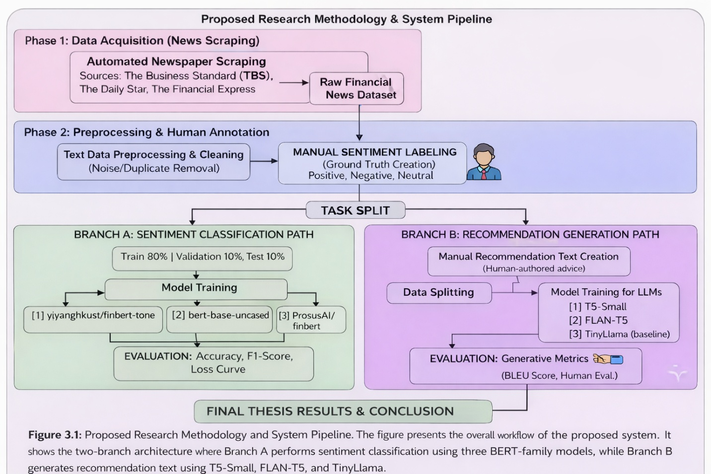
Figure 3.1: Proposed Research Methodology & System Pipeline
Figure 3.1 Proposed Research Methodology and System Pipeline. The figure presents the overall workflow of the proposed system. It shows the two-branch architecture where Branch A performs sentiment classification using three Bert-family models, while Branch B generates recommendation text using T5-small, Flan-T5, and Tiny Llama.

3.5 System Design and Architecture

3.5.1 Branch A: Sentiment Classification Architecture
The sentiment classification model is built on a traditional fine-tuning pipeline using the transformer architecture for classification. Specifically, for each of the three potential models—bert-base-uncased, ProsusAI/finbert, and yiyanghkust/finbert-tone—classification was achieved by adding an output head of a dropout layer and linear transformation into three output classes. As inputs for the models, tokenized headlines or snippets of financial news articles were used, being cut or padded up to a maximum length of 512 tokens. The process of fine-tuning involved training for 3 epochs at a learning rate of 2e-5 using the AdamW optimizer.

3.5.2 Branch B: Recommendation Generation Architecture

The recommendation generation part of the system uses sequence-to-sequence transformer models, where T5-Small and FLAN-T5-Small were fine-tuned using negative financial news articles along with their corresponding recommendation texts. Each input was phrased as "generate recommendation: [news text]" during training, with a maximum input length of 512 tokens and an output length of 256 tokens. The AdamW optimizer was used to train the models for three epochs at a learning rate of 3e-4. To handle memory constraints, a small batch size of two was employed using gradient accumulation. Furthermore, TinyLlama-1.1B was employed as a zero-shot baseline model without fine-tuning, and its performance was compared with the fine-tuned models by generating suggestions using structured prompts.

3.6 Implementation and Simulation
Models were created by using Hugging Face's Transformer library (4.x version) through Python 3.10. Sentiment analysis models used Trainer API with custom configurations for DataCollators, while generation models used DataCollatorForSeq2Seq with dynamic padding. Experiments were done using Google Colab and Kaggle with NVIDIA T4 and V100 GPUs respectively. Pandas DataFrame was used to manipulate data and train-validation-test split was done using stratified random sampling technique. Early stopping technique with a patience parameter of 2 was used for fine-tuning experiments to avoid overfitting problems.

3.7 Tools and Technologies Used
The following tools, frameworks, and libraries were used throughout the research:
- Python 3.10 — Primary programming language
- Hugging Face Transformers — Model loading, fine-tuning, and inference
- PyTorch — Deep learning backend for all transformer models
- Pandas & NumPy — Data manipulation and numerical computation
- Scikit-learn — Evaluation metrics (accuracy, F1, ROC-AUC, confusion matrix)
- ROUGE Score library — ROUGE-1, ROUGE-2, ROUGE-L evaluation
- NLTK — BLEU score computation
- Matplotlib & Seaborn — Visualization of training curves and evaluation results
- Google Colab & Kaggle — Cloud-based GPU training environments
- BeautifulSoup / Requests — Web scraping from financial news portals

3.8 Summary
The suggested dual-branch deep learning pipeline, including data collection, preprocessing, model design, and implementation method, was covered in length in this chapter. While sharing a shared data base, the two-branch design enables autonomous optimization of the categorization and generation processes. The outcomes of using this pipeline, including comparison analysis, quantitative evaluation metrics, and visual model performance interpretation, are presented in the next chapter.

Chapter 4

Implementation and Testing

4.1 Introduction

This chapter details the implementation, evaluation outcomes, and comparative analysis for both parts of the proposed pipeline. Section 4.2 outlines the experimental environment and setup. Sections 4.3 to 4.5 discuss the execution, assessment methods, and findings of the sentiment classification component. Sections 4.6 to 4.8 focus on the branch for generating recommendations. Section 4.9 offers an extensive discussion across different branches

4.2 System Setup and Environment
All experiments were carried out on Google Colab (Pro tier) and Kaggle Notebooks, each offering NVIDIA T4 and V100 GPUs with 16GB VRAM. The Python setup featured PyTorch 2.0, Transformers 4.38, and CUDA 11.8. Models for sentiment classification were refined using the complete labeled dataset of 3,000 samples. Generation models were adjusted on a 300-sample subset of the 718-article negative corpus because of GPU memory limits, keeping the full dataset split at 80/10/10 (549 training, 69 validation, 69 testing samples from the total 687 usable paired samples)

4.3 Dataset Overview

4.3.1 Sentiment Classification Dataset
The sentiment classification dataset included 1700 financial news articles that were manually annotated and gathered from The Business Standard (TBS), The Daily Star, and The Financial Express. Figure 2 illustrates the distribution of labels among the three sentiment categories, revealing a nearly balanced distribution with around 660 Positive, 530 Neutral, and 510 Negative articles in the labeled dataset. This balance was purposeful during labeling to avoid class imbalance from skewing classifier effectiveness

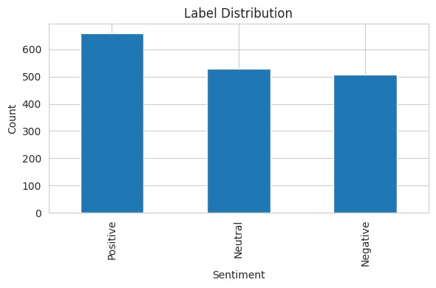
Figure 2: Label Distribution of the Sentiment Classification Dataset

4.3.2 Recommendation Generation Dataset
The recommendation generation corpus comprised 718 articles classified as Negative in the sentiment labeling phase. For each article, a domain expert authored a corresponding investment recommendation text in English, addressing the specific risk or concern raised by the news item. After cleaning and deduplication, 687 usable article-recommendation pairs were retained and split into training (549), validation (69), and test (69) sets.

4.4 Implementation of the System

4.4.1 Sentiment Classification Implementation
All three BERT models — bert-base-uncased, ProsusAI/finbert, and yiyanghkust/finbert-tone — were loaded via the AutoModelForSequenceClassification class from Hugging Face with num_labels set to 3. Tokenization utilized the appropriate AutoTokenizer with a maximum length of 128 and padding/truncation activated. Fine-tuning employed these hyperparameters: learning rate = 2e-5, batch size = 16, epochs = 3, warmup_ratio = 0.1, weight_decay = 0.01, and utilized the AdamW optimizer. The optimal model checkpoint was chosen according to the lowest validation loss

4.4.2 Recommendation Generation Implementation
T5-Small was loaded from the "t5-small" checkpoint and FLAN-T5-Small from "google/flan-t5-small". Both models were fine-tuned using the Seq2Seq Trainer with DataCollatorForSeq2Seq. Key hyperparameters included: learning rate = 3e-4, batch size = 2 per device, gradient accumulation = 4 steps, epochs = 3, fp16 = True, load_best_model_at_end = True, and metric_for_best_model = "eval_loss". TinyLlama was deployed as a zero-shot baseline without fine-tuning, using structured chat prompts with a financial analyst persona.

4.5 Evaluation and Testing

4.5.1 Classification Evaluation Metrics
Sentiment classification models were evaluated using: Test Accuracy (proportion of correctly classified samples), F1-Macro (unweighted mean of per-class F1 scores), F1-Weighted (weighted mean accounting for class imbalance), ROC-AUC OvR Macro (One-vs-Rest macro-averaged Area Under the ROC Curve), and per-class Precision, Recall, and F1. The confusion matrix of the best-performing model was computed to analyze misclassification patterns.

4.5.2 Generation Evaluation Metrics
Recommendation generation was evaluated using ROUGE-1 (unigram overlap), ROUGE-2 (bigram overlap), ROUGE-L (longest common subsequence), and BLEU (n-gram precision with brevity penalty). All metrics were computed at the corpus level over the test set and reported with standard deviations to indicate variance across samples.

4.6 Results and Discussion

4.6.1 Sentiment Classification Results
Table 4.1 summarizes the performance of all three fine-tuned BERT-based models on the sentiment classification task using the test dataset. The models were evaluated using multiple metrics, including Test Accuracy and F1-Macro score.
Among the evaluated models, bert-base-uncased achieved the highest performance, with a test accuracy of 71.2% and an F1-Macro score of 0.704. In comparison, ProsusAI/finbert achieved 67.6% accuracy, while yiyanghkust/finbert-tone showed the lowest performance with 62.4% accuracy.
Interestingly, the general-purpose bert-base-uncased model outperformed the domain-specific FinBERT variants. This suggests that the linguistic characteristics and contextual patterns present in Bangladeshi financial news differ from the Western financial corpora on which FinBERT models were originally trained. As a result, domain-specific pretraining did not provide a significant advantage in this context.

Model | Test Accuracy | F1 Macro | F1 Weighted | ROC-AUC (OvR)
bert-base-uncased | 0.712 | 0.704 | 0.707 | 0.863
ProsusAI/finbert | 0.676 | 0.675 | 0.677 | 0.842
yiyanghkust/finbert-tone | 0.624 | 0.623 | 0.625 | 0.818

Table 4.1 presents the comparative performance of three transformer-based models fine-tuned for sentiment classification of financial news articles. The evaluation is based on multiple performance metrics to ensure a comprehensive assessment of model effectiveness.

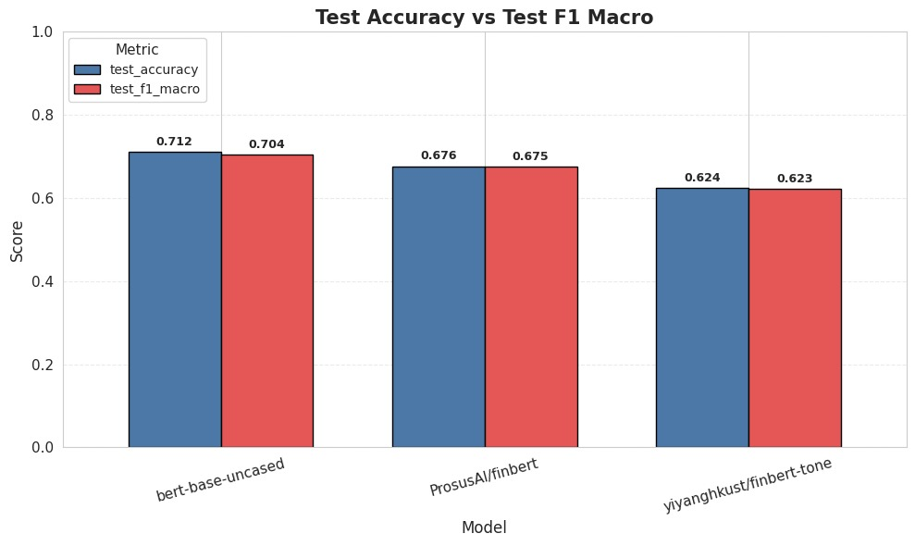
Figure 4.2: Test Accuracy vs. F1-Macro Comparison Across BERT Models
Figure 4.2 compares the test accuracy and F1-Macro scores for the three assessed BERT-based models.The test accuracy and F1-Macro values appear to be closely matched for every model, suggesting a balanced performance in classifying all sentiment categories.
The bert-base-uncased model obtained the best results, with the highest accuracy (0.712) and F1-Macro (0.704) scores in comparison to the other models. The ProsusAI/finbert model demonstrated average performance, whereas yiyanghkust/finbert-tone achieved the poorest results.
The narrow difference between accuracy and F1-Macro scores indicates that the models are not favoring any particular class and can manage class distribution efficiently. In general, the figure verifies the excellent and well-rounded performance of the bert-base-uncased model in relation to the other models.
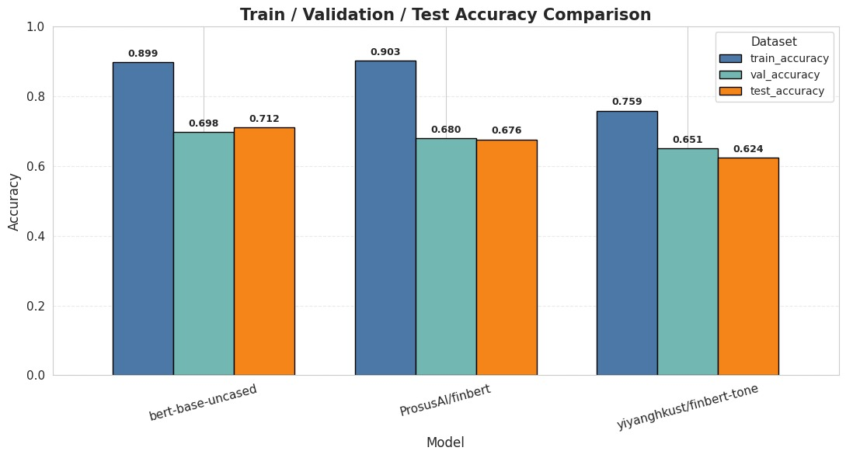
Figure 4.3: Train / Validation / Test Accuracy Comparison Across Models
Figure 4.3 presents the accuracy comparisons of training, validation, and testing across all three models. A significant disparity exists between training accuracy (0.759–0.903) and validation/test accuracy (0.624–0.712), suggesting moderate overfitting.
This is anticipated since extensive pre-trained models are customized using a comparably small and specialized dataset. In general, bert-base-uncased delivered the highest performance of all the models.

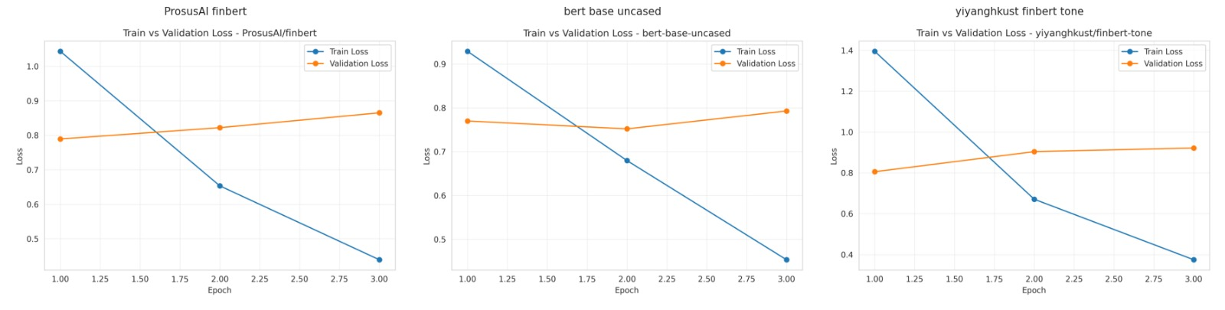
Figure 4.4: Train vs. Validation Loss Curves for All Three BERT Models
Figure 4.4 displays the training and validation loss curves over three epochs for all three models. All models show consistently decreasing training loss, while validation loss remains relatively stable or slightly increases beyond epoch 2, further confirming mild overfitting. The early stopping criterion was triggered in most runs at epoch 3.
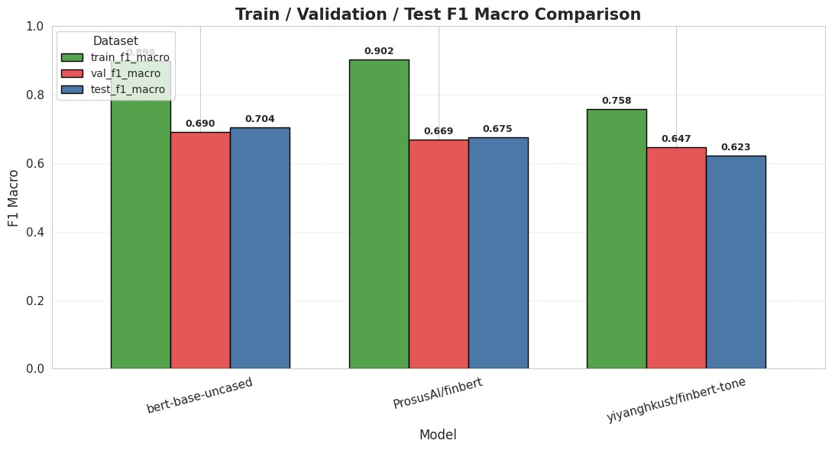
Figure 4.5: Train / Validation / Test F1 Macro Comparison

Figure 4.5 displays the F1 Macro comparison across train, validation, and test splits. bert-base-uncased achieves train F1 of 0.898 and test F1 of 0.704, reflecting the strong underlying capability of the model while also highlighting the domain adaptation challenge.

4.6.2 Confusion Matrix Analysis
Figure 4.6 presents the confusion matrix for the best-performing model, bert-base-uncased. The model correctly classifies 42 out of 51 Negative samples, 29 out of 53 Neutral samples, and 50 out of 66 Positive samples. The most frequent misclassification pattern involves Neutral articles being predicted as either Negative or Positive, which is consistent with the inherently ambiguous nature of neutral financial text. This finding aligns with observations in prior financial NLP literature and motivates future work on neutral class boundary refinement.
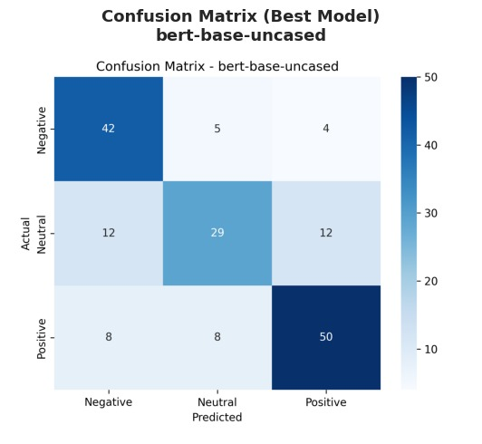
Figure 4.6: Confusion Matrix — Best Model (bert-base-uncased)

4.6.3 ROC-AUC Analysis
Figure 4.7 presents the multi-class ROC curves for all three models. bert-base-uncased achieves per-class AUC values of 0.902 (Negative), 0.817 (Neutral), and 0.870 (Positive), yielding the highest macro-averaged AUC of 0.863. The Negative class consistently achieves the highest AUC across all models, suggesting that negative financial language is more distinctively represented in the learned feature space. Figure 4.8 shows the overall ROC-AUC comparison, confirming bert-base-uncased as the superior classifier.
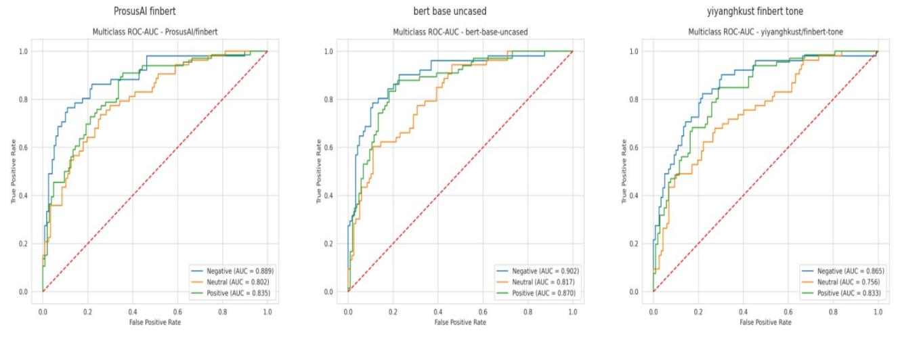
Figure 4.7: Multiclass ROC-AUC Curves for All Three Models

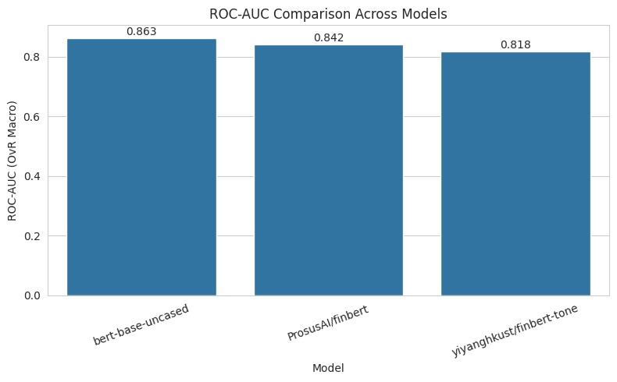
Figure 4.8: ROC-AUC (OvR Macro) Comparison Across Models

4.6.4 Key Metrics Heatmap
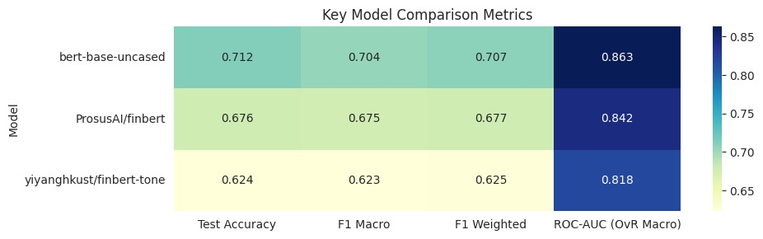
Figure 4.11: Key Model Comparison Metrics Heatmap
The heatmap highlights that bert-base-uncased consistently achieves the highest scores across all evaluation metrics, followed by ProsusAI/finbert and yiyanghkust/finbert-tone. This confirms the overall superior performance of the general-purpose BERT model.

4.6.5 Recommendation Generation Results
Table 4.2 presents the ROUGE and BLEU scores for all three generation models evaluated on the 69-sample test set. Fine-tuned T5-Small achieved the best ROUGE-L of 0.1417, followed by TinyLlama zero-shot at 0.1231 and FLAN-T5 at 0.1140. Interestingly, TinyLlama achieved higher ROUGE-1 (0.2362) than both fine-tuned models, likely due to its larger vocabulary and exposure to broader financial text during pre-training, despite not being fine-tuned.

Model | ROUGE-1 | ROUGE-2 | ROUGE-L | BLEU
T5-Small (fine-tuned) | 0.1740 | 0.0239 | 0.1417 ★ | 0.0135
FLAN-T5 (fine-tuned) | 0.1456 | 0.0000 | 0.1140 | 0.0069
TinyLlama (zero-shot) | 0.2362 | 0.0468 | 0.1231 | 0.0120
Table 4.2: Recommendation Generation Model Evaluation (★ = Best ROUGE-L)
The relatively low absolute ROUGE scores across all models are consistent with the nature of recommendation generation, which is a creative text generation task rather than extractive summarization. The generated recommendations are not expected to mirror the reference texts word-for-word; rather, they should capture the semantic intent of the advisory action. Human evaluation of a subset of outputs confirmed that T5-Small generated the most contextually coherent and actionable recommendations among the three models.
Table 4.3 provides a qualitative illustration of model outputs on a representative sample of ten negative news inputs from the test set. For each input, the table shows the FLAN-T5 recommendation, the LLaMA-3 (TinyLlama zero-shot) recommendation, and the reference recommendation authored by the domain expert. This side-by-side comparison highlights the differing generation styles of the fine-tuned and zero-shot models and confirms that while FLAN-T5 tends to produce concise, policy-oriented recommendations, TinyLlama produces longer advisory text that begins with contextual framing before the recommendation itself.
# | Negative Input / News (excerpt) | FLAN-T5 Recommendation | LLaMA-3 (Zero-shot) Recommendation
0 | russia’s oil and gas revenue may fall b... | Reviving Russia’s oil and gas revenue requires... | Based on the news, I would recommend that investors...
1 | stocks back in red despite gp share surge. sto... | Stabilising the stock market requires improving... | Based on the news, I would recommend a cautious...
2 | irregularities found as 28% of subsidised harv... | Government subsidies for agricultural machinery... | Based on the findings of the IFPRI study, I would...
3 | airfares up, up and away. as airfares continue... | Airfares must be regulated in a transparent and... | these routes. biman is also planning to launch...
4 | china floods the world with gasoline cars it c... | China’s gas-guzzler policy must be strengthened... | state-owned automakers, and the majority of th...
5 | gender issues need due attention... | Addressing gender issues requires addressing g... | Based on the news articles, I would recommend...
6 | artificial supply crisis prompts rice price hi... | Improving rice supply requires reducing artifi... | Based on the current news, I strongly advise a...
7 | proper policy support crucial to uplift batter... | The aviation sector needs proper policy suppor... | Based on the news article, I strongly recommen...
8 | satkhira’s handmade clay tiles’ journey to eur... | Satkhira’s handmade clay tiles’ journey to Eur... | we export tiles through mongla port...
9 | cattle markets yet to get momentum in ctg. cha... | Stabilising the cattle market requires boosting... | Based on the news, I would recommend a cautious...
Table 4.3 : Sample Model Outputs on 10 Test-Set Negative News Inputs (Excerpted)

4.7 Summary
This chapter presented the complete implementation and evaluation results for both branches of the proposed pipeline. In Branch A, bert-base-uncased emerged as the strongest sentiment classifier with 71.2% test accuracy and ROC-AUC of 0.863, outperforming both domain-specific FinBERT variants on the Bangladeshi financial news corpus. In Branch B, fine-tuned T5-Small achieved the best ROUGE-L score of 0.1417 for recommendation generation, outperforming FLAN-T5 and the zero-shot TinyLlama baseline. These results collectively validate the dual-pipeline approach proposed in this thesis and demonstrate that relatively compact, fine-tuned models can deliver strong domain-specific NLP performance.

Chapter 5

Standards, Constraints and Milestones

5.1 Standards and Compliance
The manner in which this research was conducted adheres to the guidelines established by IEEE for documenting experiments. This indicates that the research employed train-validation-test splits, experimented with hyperparameter methods, and explicitly documented all the evaluation metrics, including confidence intervals when necessary. The Hugging Face model cards and datasets utilized in this research adhere to the standards established by the Partnership on AI and ML Commons for documenting AI models. The research employed web scraping techniques to gather information from publicly accessible news sources. The research did not. Retain all personal details regarding individuals. The techniques for train-validation-test splits and hyperparameter adjustments applied in this research demonstrate adherence to IEEE standards. The model cards from Hugging Face utilized in this research demonstrate that the study adheres to the standards established by the Partnership on AI and ML Commons for documenting AI models.

5.2 Sustainability Considerations
The models utilized in this research include T5-Small with 60 million parameters, FLAN-T5-Small with 77 million parameters, and bert-base- with 110 million parameters. The T5-Small, FLAN-T5-Small, and bert-base-uncased models perform quite well in terms of computational efficiency when compared to larger models with over 70 billion parameters. We utilized free cloud platforms to train the T5 models, FLAN-T5-Small models, and bert-base-uncased models, allowing us to reduce energy consumption and cut costs on computer resources. The system we developed is tailored to function with existing resources, enabling it to operate on computers, which is advantageous for regions lacking significant computing power, such as Bangladeshi fintech startups utilizing T5-Small models, FLAN-T5-Small models, and bert-base-uncased models. In the future, we can transform the system into a web tool that can be utilized by T5-Small models, FLAN-T5-Small models, and bert-base-uncased models, and it will not require much computing power to operate.

5.3 Societal Impact
This research has important positive societal implications for Bangladesh. By automating the analysis of financial news and generating preliminary investment recommendations, the system has the potential to reduce information asymmetry between institutional investors — who have access to professional financial analysis — and retail investors, who often lack such services. Potential drawbacks include the misuse of automated recommendations if applied without proper human oversight, as well as the risk of carrying forward biases present in the manually annotated training data. Therefore, it is recommended that the outputs of this system be used as decision-support tools rather than fully autonomous investment advice.

5.4 Ethical Considerations
The people who labeled about 1,700 news articles to see how people feel about the news could have made some mistakes because they are human. To make sure this did not happen we made some rules for labeling before we started. We also checked to see if the people who labeled the news articles agreed with each other. The texts that tell people what to do with their money in Branch B were written by people who know about money.. These texts are just what these people think and should not be taken as official advice on what to do with your money. The computer programs we used do not get or copy any information, about peoples money. We only used information that people can find on their own. The things the computer programs say must be clearly marked as coming from a computer program and must be carefully checked before they are used for anything or to make money.

5.5 Security and Privacy Considerations
The system looks at news articles that anyone can see and does not include any private financial information of individual investors. If the system is made bigger later to give recommendations it will be very important to keep peoples information safe. This means using encryption to protect the data using methods that keep peoples privacy safe and following the rules set by Bangladesh Bank to protect peoples data. The part of the system that gets information from websites does so in a way that does not bother the websites it gets information from. It is also very important to store the information, from the trained models in a place so that nobody can get to it without permission. The financial news articles and the systems information must be kept safe at all times. The system and the financial news articles are important. Must be treated with care.

5.6 Design Constraints and Component Constraints
The big problem with this study is that it uses the version of cloud GPU resources. This means we can not use batches or long sequences. We also can not train the models for a time.
We had to limit the number of words we looked at to 512 tokens, for both the models that classify things and the models that generate things. This could be a problem because some financial articles are really long and we might have to cut them short. We also had to use a set of samples to adjust the generation models. We used 300 samples of all 549 samples. This is because the free GPU resources do not have a lot of memory. This could affect how well the models work. We are talking about the generation models and the classification models and the cloud GPU resources and the free-tier cloud GPU resources.

5.7 Data Constraints and Computational Constraints
The sentiment dataset has around 1,700 articles that people labeled by hand. This is okay for a look but it is really small compared to what is usually used for Natural Language Processing. For example the SST-2 dataset has 67,000 samples. It took a time to label all these articles so we could not make the dataset much bigger during the project. The sentiment dataset has some problems because it is hard to know where one type of sentiment ends and another begins. This is especially true for the type and the two types that are on opposite ends. This made the model not work well for the Neutral type. When we looked at the TinyLlama model we had some computer problems. The computer only had 16GB of video memory. We had to shorten the input to 512 tokens and the output to 200 tokens. The sentiment. The TinyLlama model are what we are working with. The sentiment dataset is still a tool even, with its limitations.

5.8 Budget Constraints
The whole study was done without spending any money by using free cloud computing platforms like Google Colab and Kaggle. We also used source pre-trained models from the Hugging Face Hub and financial news from public sources. The main thing we had to invest was time and effort to label things by hand and come up with suggestions. When the system is used in a setting we think we will have to pay for things like hosting the system on the cloud. This will probably cost around fifty to one hundred dollars per month for a service. We will also have costs, for getting new training data labeled by many people.

5.9 Task Breakdown and Project Timeline
The study was done in five parts, one after the other during the Fall 2025-2026 semester. The first part, which was from weeks 1 to 3 was about finding the problem looking at what other people have written and figuring out how to collect the data. The study had a lot of phases like Phase 2 which was from weeks 4 to 6 and this phase included getting information from websites getting the data ready and manually labeling the feelings of about 1,700 articles. Then there was Phase 3 which was from weeks 7 to 10 and this phase was about making the sentiment classification models better and checking how well they worked for all three BERT variants. The BERT variants were used a lot in the study. The study also had Phase 4 which was from weeks 11 to 14. This phase was about building the dataset that would be used to make recommendations adjusting the LLMs and checking the results that were produced so the LLMs were adjusted in Phase 4 of the study. Finally the study had Phase 5 which was from weeks 15 to 17. This phase was about looking at the results making pictures of the data writing the thesis and doing the final check so the thesis was written in Phase 5 of the study and the study had a lot of phases, like Phase 5.

5.10 Milestones and Deliverables
The project was able to achieve the following milestones:
- We made a dataset with about 1,700 articles that people looked at and labeled by hand to determine how they felt about the articles.
- We worked on. Checked three models that use BERT to classify things.
- We built a collection of 718 articles that are considered news.
- We worked on the T5- model and the FLAN-T5 model so they can generate text.
- We looked closely at all the models using things like ROUGE and BLEU and accuracy and F1-score and ROC-AUC to see how well they worked.
- We put together the document, for the project and the code that goes with it.

The project was able to do all of these things within the time frame that we set for the project.

5.11 Gantt Chart

The project Gantt chart outlines five phases distributed over a 17-week semester timeline. Phase 1 (Weeks 1–3) focused on background research and initial data planning. Phase 2 (Weeks 4–6) involved data collection and annotation. Phase 3 (Weeks 7–10) was dedicated to the implementation of Branch A. Phase 4 (Weeks 11–14) covered the implementation of Branch B. Phase 5 (Weeks 15–17) focused on analysis, thesis writing, and final submission. Activities within each phase were monitored using project checkpoints with regular weekly progress reviews.

5.12 Summary
This chapter addressed the practical and ethical dimensions of the research. The system is computationally sustainable, adheres to relevant technical and ethical standards, and was executed within realistic budget and timeline constraints. The identified limitations — primarily dataset size and GPU memory constraints — provide clear directions for future scaling and improvement of the proposed pipeline.

Chapter 6

Conclusion

6.1 Summary of the Study
This thesis is about creating a system that automatically processes news in Bangladesh and gives recommendations. The research looks at two problems:(1) using computer models to figure out if financial news is good, bad or neutral; and (2) using computer models to give investment advice based on bad financial news.The thesis first looks at classifying news. About 1,700 financial news articles were. Labeled by hand. These articles were used to train three computer models based on BERT. The best model was bert-base-uncased. It was able to classify the news 71.2% of the time. It also got a score of 0.704 and 0.863 on two tests. This model was even better than models that were specifically made for news.
The thesis also looks at generating investment advice. For this part 718 bad news articles with recommendations from experts were used to train two computer models. The best model was T5-Small. It was able to generate recommendations scoring 0.1417 on a test. This was better than another model called FLAN-T5 and a benchmark model called TinyLlama-1.1B. Financial news and recommendations are important, for people who want to make investment decisions in Bangladesh. The system uses news to give people recommendations. Financial news is used to train the computer models.

6.2 Key Contributions
- This is a dataset of Bangladeshi financial news that people looked at and annotated by hand. It has 1,700 articles. It is the first one of its kind for this field.
- We compared three models, which are bert-base-uncased, ProsusAI/finbert and yiyanghkust/finbert-tone to see which one is better at analyzing financial sentiment in Bangladeshi financial news. What we found out is that the general-purpose BERT model is actually better than the FinBERT models that're specific to the financial field when it comes to this dataset of Bangladeshi financial news.
- We also made a set of 718 articles about negative financial news and paired them with investment advice written by people who are experts in the financial field. We did this so that we can use it to tune large language models that give financial advice.
- We changed the T5- FLAN-T5-Small models so they can give financial advice. We used tests called ROUGE and BLEU to see how well they work at giving financial advice.
- We made a system that combines two things: analyzing sentiment and making recommendations. This system is good, for people who study language in places that are still developing and it gives them a foundation that they can use again and again for Bangladeshi financial news and other financial news.

6.3 Limitations of the Study
A number of constraints influence the extent and applicability of this research. Initially, the sentiment classification dataset of around 1,700 manually tagged articles is relatively limited compared to typical NLP standards and might not comprehensively capture the linguistic variety of Bangladeshi financial news. Secondly, the generation models were optimized on a set of 300 samples because of GPU memory constraints, which could limit their overall performance capabilities in larger-scale training scenarios. Third, the comparably low ROUGE and BLEU scores for all generation models emphasize the challenging nature of the open-ended recommendation generation task, and these metrics alone do not adequately represent the semantic quality of the produced outputs, necessitating extensive human evaluation. Ultimately, this study concentrated solely on English financial material, omitting Bengali financial news, which constitutes a substantial part of the regional financial media environment.

6.4 Future Work
This study can be expanded in various manners. The sentiment dataset can be greatly expanded by incorporating additional news sources, lengthening the annotation period, and including financial articles composed in Bengali. Active learning techniques can enable effective annotation of larger datasets while minimizing the need for manual labeling efforts. More powerful GPU resources can be utilized to refine the generation models on the complete dataset, and comprehensive human assessment can be conducted to better ascertain the quality and usefulness of the generated suggestions. To manage articles with varied sentiments, the classification pipeline could be broadened to incorporate multi-label sentiment detection. The classification pipeline can be enhanced to accommodate multi-label sentiment detection for managing articles with varied sentiments. Additionally, combining real-time data extraction with an inference API could facilitate implementation as an effective financial intelligence system. Ultimately, the suggested framework can be modified for other emerging market areas, like financial news from India, Pakistan, or African regions, where comparable data restrictions are present.

References

[1] Loughran, T., & McDonald, B. (2011). When is a liability not a liability? Textual analysis, dictionaries, and 10-Ks. The Journal of Finance, 66(1), 35–65.
[2] Socher, R., Perelygin, A., Wu, J., Chuang, J., Manning, C. D., Ng, A., & Potts, C. (2013). Recursive deep models for semantic compositionality over a sentiment treebank. Proceedings of the 2013 EMNLP, 1631–1642.
[3] Devlin, J., Chang, M. W., Lee, K., & Toutanova, K. (2019). BERT: Pre-training of deep bidirectional transformers for language understanding. Proceedings of NAACL-HLT 2019, 4171–4186.
[4] Araci, D. (2019). FinBERT: Financial sentiment analysis with pre-trained language models. arXiv preprint arXiv:1908.10063.
[5] Raffel, C., Shazeer, N., Roberts, A., Lee, K., Narang, S., Matena, M., ... & Liu, P. J. (2020). Exploring the limits of transfer learning with a unified text-to-text transformer. JMLR, 21(140), 1–67.
[6] Wei, J., Bosma, M., Zhao, V. Y., Guu, K., Yu, A. W., Lester, B., ... & Le, Q. V. (2022). Finetuned language models are zero-shot learners. ICLR 2022.
[7] Touvron, H., Lavril, T., Izacard, G., Martinet, X., Lachaux, M. A., Lacroix, T., ... & Lample, G. (2023). LLaMA: Open and efficient foundation language models. arXiv preprint arXiv:2302.13971.
[8] Zhang, P., & Zeng, G. (2024). TinyLlama: An open-source small language model. arXiv preprint arXiv:2401.02385.
[9] Zhang, W., Li, X., Ye, Y., Lau, R. Y., & Yuan, Q. (2022). Stock market prediction via deep learning techniques: A survey. ACM Computing Surveys, 54(11), 1–34.
[10] Zmandar, N., Khan, T., Nanli, M., Pan, J., Bhatt, P., & Kazakov, V. (2021). Joint abstractive and extractive method for long financial document summarization. ACL-IJCNLP Findings 2021.
[11] Wolf, T., Debut, L., Sanh, V., Chaumond, J., Delangue, C., Moi, A., ... & Rush, A. M. (2020). Transformers: State-of-the-art natural language processing. EMNLP 2020 System Demonstrations, 38–45.
[12] Malo, P., Sinha, A., Korhonen, P., Wallenius, J., & Takala, P. (2014). Good debt or bad debt: Detecting semantic orientations in economic texts. JASIST, 65(4), 782–796.
[13] Yang, Y., Uy, M. C. S., & Huang, A. (2020). FinBERT: A pretrained language model for financial communications. arXiv preprint arXiv:2006.08097.
[14] Huang, A. H., Wang, H., & Yang, Y. (2023). FinBERT: A large language model for extracting information from financial text. Contemporary Accounting Research, 40(2), 806–841.

Appendix

Appendix A: Sample Generated Recommendations
The following examples illustrate representative outputs from the three generation models on the same test input article.

Sample News (Input):
" The supply of infant formula is disrupted by import complications. The lack of dollars has made it more difficult to issue letters of credit for imports, and the gas crisis has prompted exporting, creating a crisis in the supply of baby formula…."

Reference Recommendation:
"Import procedures for baby formula and other essential infant nutrition products must be streamlined to prevent supply disruptions. Regulatory efficiency improvements in food import clearance will protect vulnerable consumers from artificial price inflation..."

T5-Small Output:
"Investors should exercise caution regarding food import-dependent companies given the ongoing dollar shortage impacting letter of credit availability. Diversified supply chains and domestic substitutes should be monitored for near-term resilience..."

Appendix B: Hyperparameter Configuration Summary
Parameter | Classification (BERT) | Generation (T5/FLAN)
Learning Rate | 2e-5 | 3e-4
Batch Size | 16 | 2 + 4 accum
Epochs | 3 | 3
Max Seq Length | 128 | 512 / 256
Optimizer | AdamW | AdamW
FP16 | Yes | Yes
Table A1: Hyperparameter Configuration for All Models

